

BRIGHT WORLD

**Batch Code: 202103B**

**Faculty: Miss Hunza**

**Group Member:**

|  |  |
| --- | --- |
| **1306511** | **Usman Arif** |
| **1310834** | **Muhammad Yaseen** |
|  |  |

Contents

Acknowledgment---------------------------------------------------------------------5

E-project Analysis------------------------------------------------------------------- 5

Flowchart----------------------------------------------------------------------------5

**Screenshot’s**------------------------------------------------6

Home ---------------------------------------------------------------------6

Services------------------------------------------------------------------6

LED Lights---------------------------------------------------------7

Electronics Appliances---------------------------------------------------8

Disco LED Lights---------------------------------------------–-------------------9

Contact us----------------------------------------------------------------10

About us------------------------------------------------------------------10

Login $ Signup-----------------------------------------------------------10

**Source code with comments** -----------------------------------11

Home ---------------------------------------------------------------------11

Services--------------------------------------------------------------------12

Contact us------------------------------------------------------------------ 12

LED Lights-------------------------------------------------------------------13

Electronics Appliances------------------------------------------------------14

Disco LED Lights-------------------------------------------------------------15

Contact us------------------------------------------------------------------ 17

About us-------------------------------------------------------------------- 17

**User Guide**---------------------------------------------------------- 18

**Developer guide**---------------------------------------------------- 18

Home Page------------------------------------------------------------------18

Services---------------------------------------------------------------------18

LED Lights------------------------------------------------------------------- 18

Electronics Appliances------------------------------------------------------ 18

Disco LED Lights------------------------------------------------------------- 19

Contact us------------------------------------------------------------------ 19

About us-------------------------------------------------------------------- 19

**E-project on LED Lights**

# **Acknowledgement:**

I thanks to Allah Almighty who made me able to complete this project. I would want to express my heartfelt gratitude to my instructor (Miss Hunza), who provided me with the excellent opportunity to produce this knowledgeable project on the topic Auction Table, as well as assisting me in conducting extensive research and learning about many new things. I am truly grateful to them.

**Project Analysis:**

A **Light Emitting Diode** (**LED**) is a semiconductor device which converts electricity into light. Each diode is about 1/4 inch in diameter and uses about ten milliamps to operate at about a tenth of a watt. LEDs are small in size, but can be grouped together for higher intensity applications.

LED fixtures require a driver which is analogous to the [ballast](https://electrical-engineering-portal.com/power-supply-of-luminaires-with-magnetic-ballasts) in fluorescent fixtures. The drivers are typically built into the fixture (like fluorescent ballasts) or they are a plug transformer for portable (plug‐in) fixtures. The plug‐in transformers allow the fixture to run on standard 120 volt [alternating current](https://electrical-engineering-portal.com/ac-vs-dc) (AC), with a modest (about 15 to 20 percent) power loss.

**Flow Chart:**



Home Page

Decision Point

Service section

Fancy LED

LED Bulb

LED Disco

LED Tube

Save For Letter

Add to Cart

Check Out

**Screenshot’s**

**Home Page:**

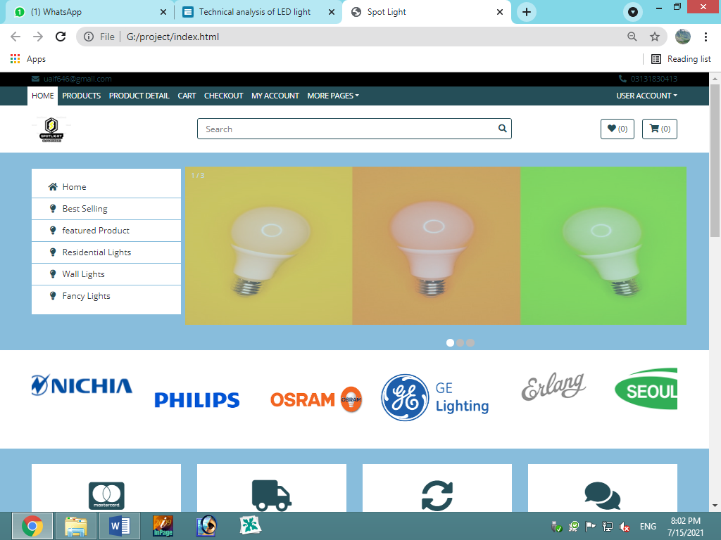

**Product:**

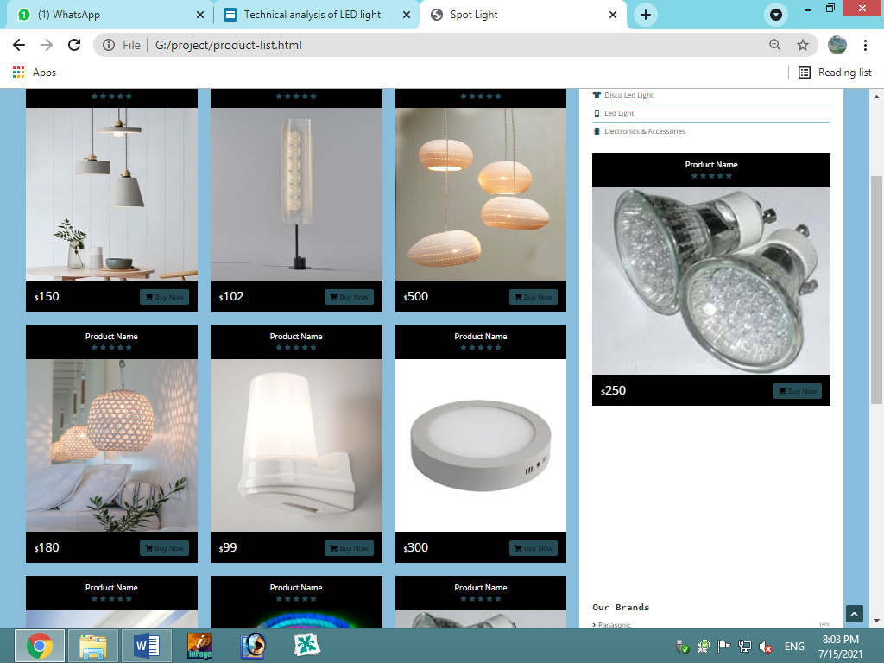

**Product Details:**

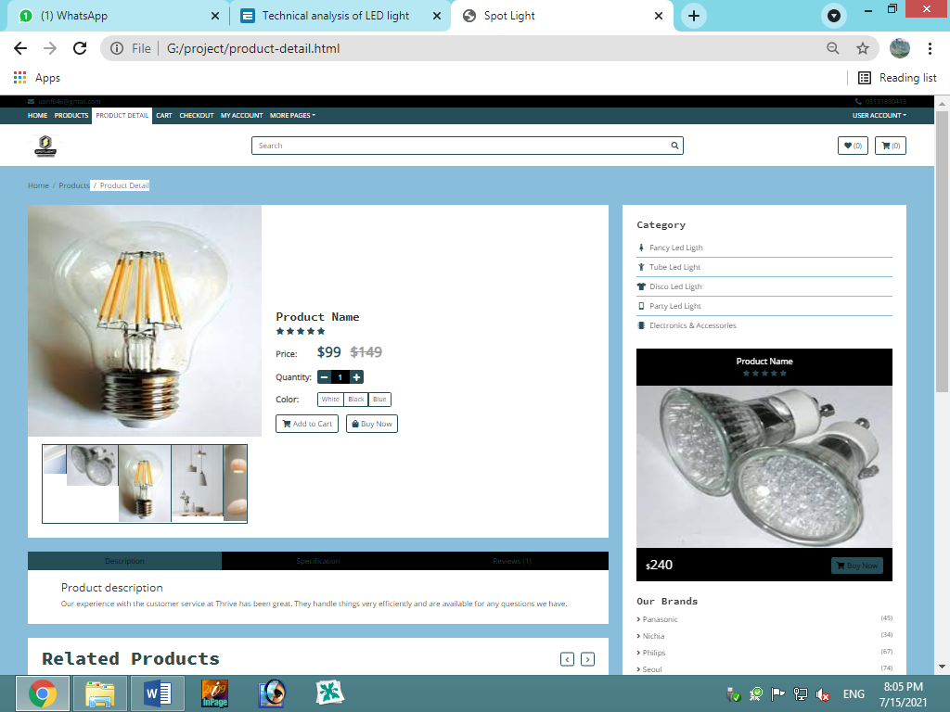

**Cart:**

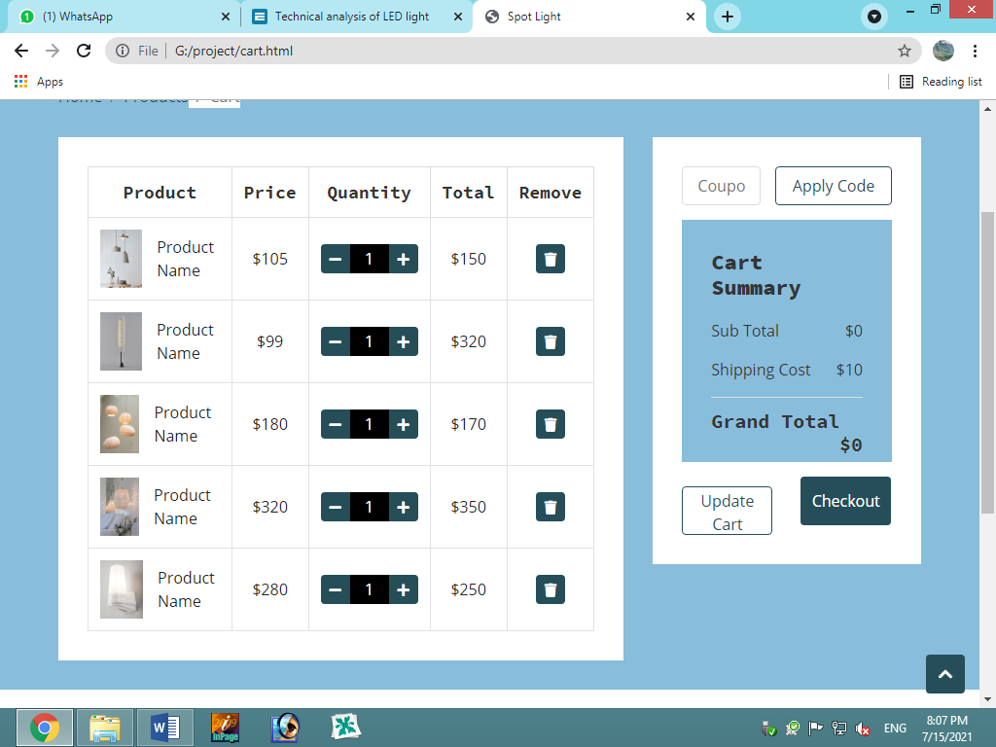

**Contact Us:**

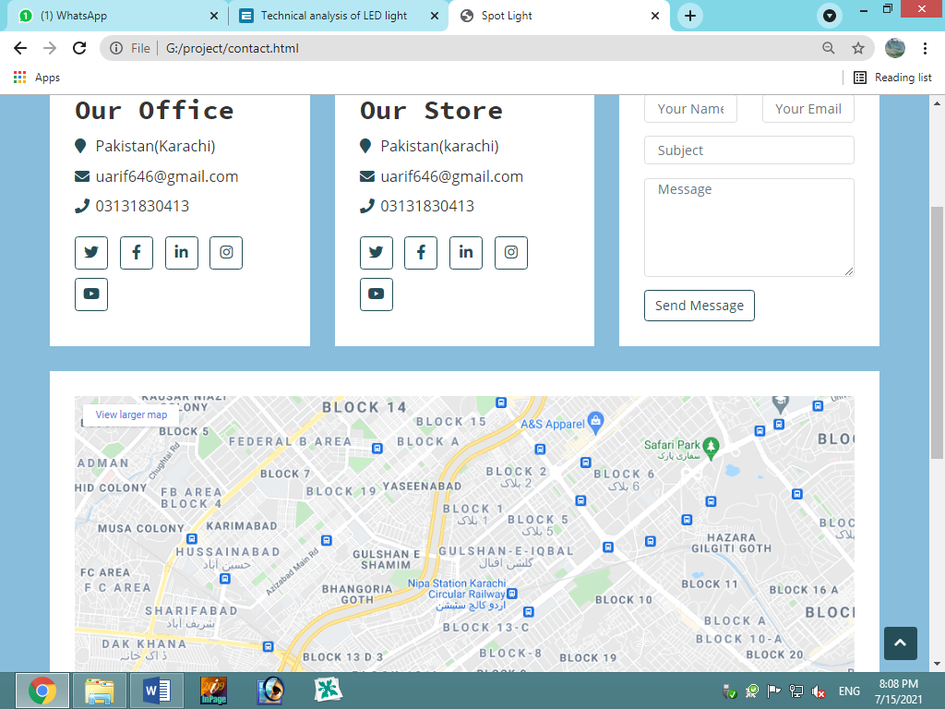

# 

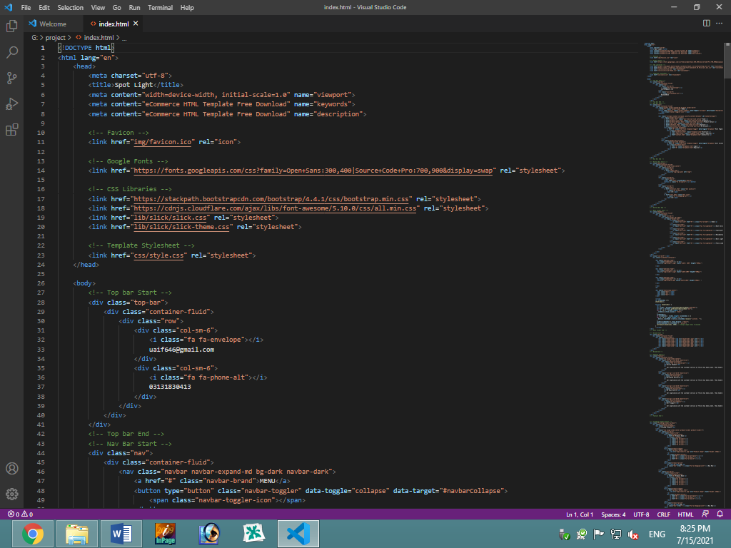**Source Code Screenshots:**

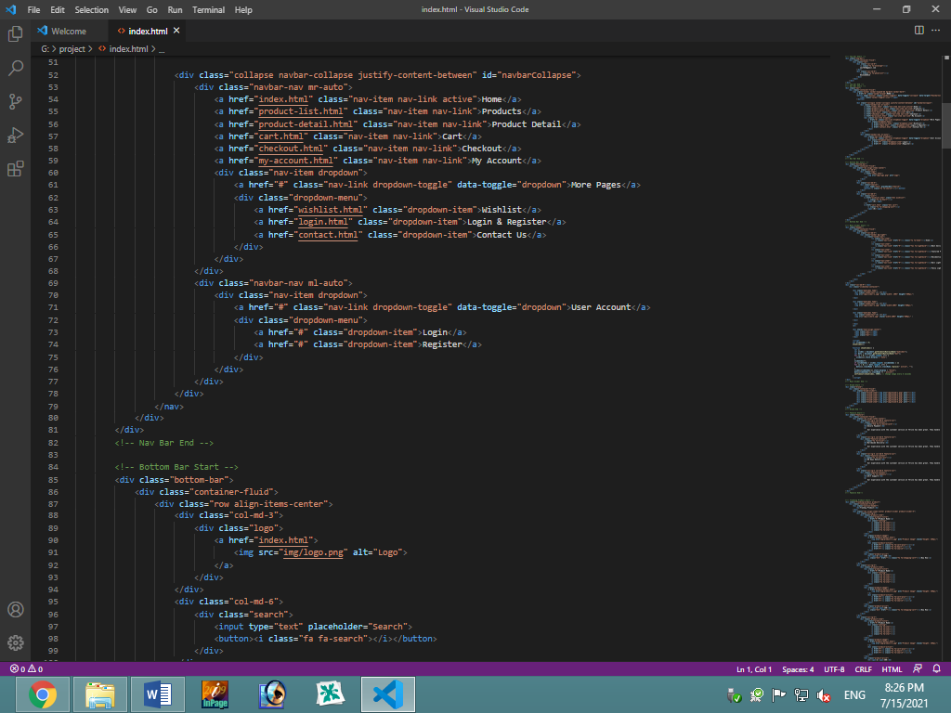

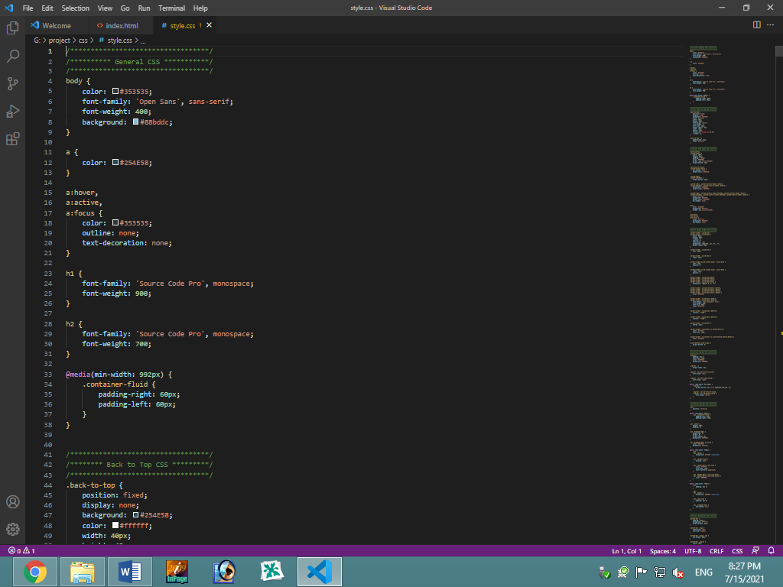**CSS Source Code:**

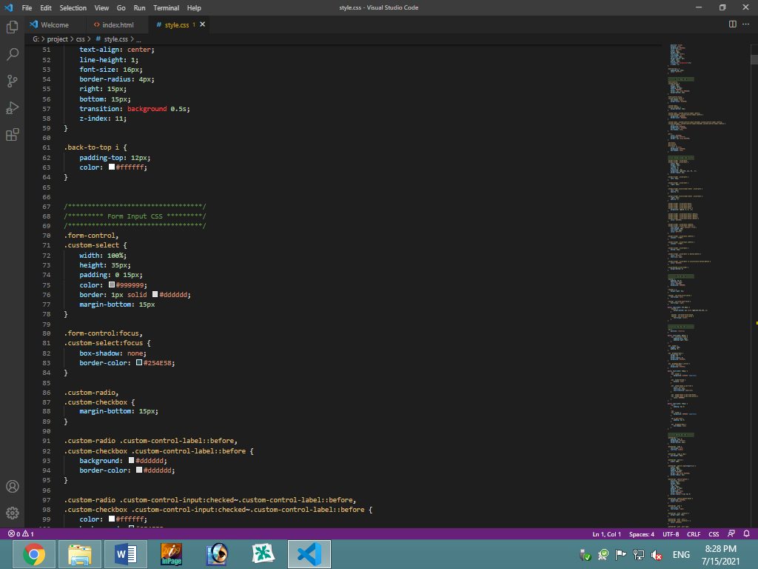

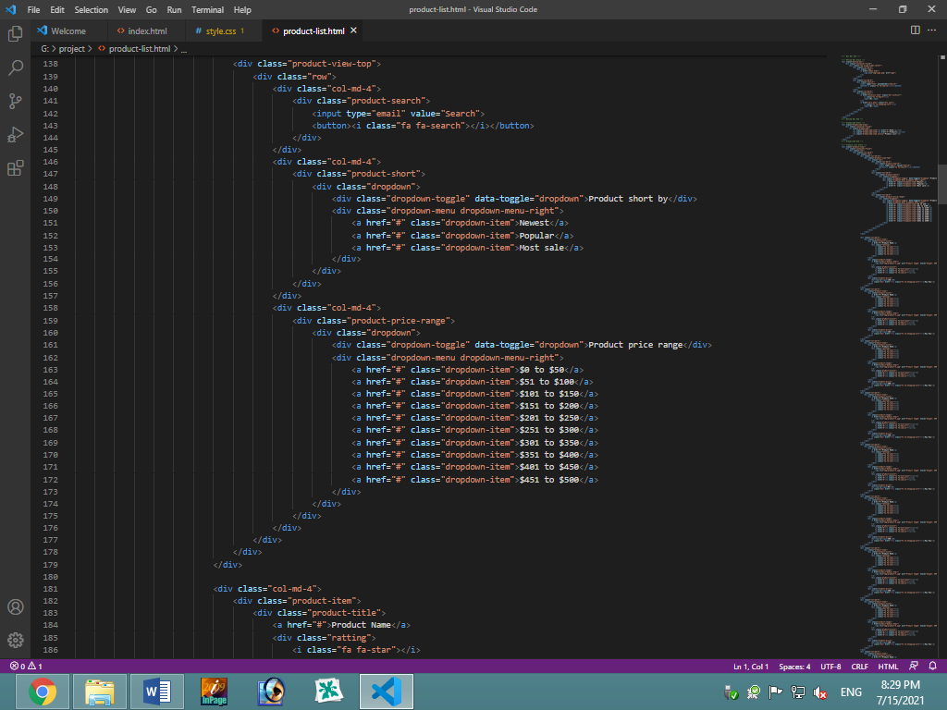**Product:**

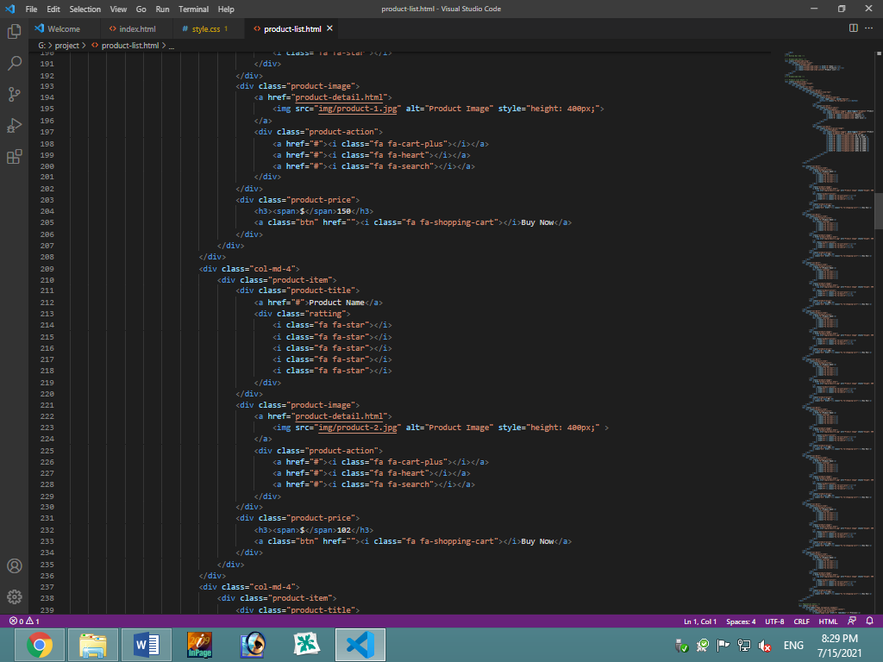

# **User guide:**

A user guide contains textual and visual information, such as diagrams or screen shots, to help the user complete tasks related to the product or service, which are grouped along functional or workflow lines. As I already explained.

# **Developer guide:**

## **Homepage:**

Homepage is a welcome page in which there will some brief descriptions which shows the attraction of the Actuation table which include LED Lights, Fancy Lights, Electronics appliances, in this website

## Attributes

Individual LEDs are considerably more efficient; however, the lamp or fixture design is reduced by the driver and electronics. In addition, LEDs do not produce heat like [incandescent bulbs](https://electrical-engineering-portal.com/what-light-source-to-choose).

LEDs last considerably longer than incandescent or fluorescent lighting. LEDs don’t typically burn out like traditional lighting, but rather gradually decrease in light output. Their “useful life” is defined by the Alliance for Solid‐State Illumination Systems and Technologies ([ASSIST](http://www.lrc.rpi.edu/programs/solidstate/assist/index.asp)) as the time it takes until 70% of initial light output is reached, often 50,000 hours.

## **Services:**

In Service section, this page will show all the Items Include electronic Applies, LED Lights, Fancy LED Lights. The all-useful items explained there are present in this website.

## **Contact Us:**

In contact us page there will be a brief description with message form if you have any queries, you can ask us.

**About us:**

In about section, all about this company, their mission all information about their teams all addressed their store are included in this section.